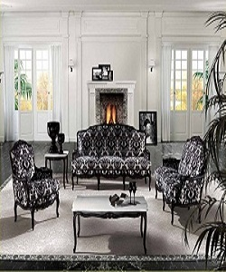

Royal Wooden Carved Modern Sofa

$196.07

Availability: In stock

Description

With immense market knowledge, we have been able to provide optimum quality Royal Wooden Carved Sofa. It comes with a bentwood slat system that provides optimal support as the slats adapt to the pressure exerted on them. It also includes side rails and additional metal legs to ensure stability and support. The comfortable cushioning of the headboard gives your body all the support needed to sit and relax. Available in multiple colors and sizes.